Measurement

- A pool has the following dimensions: 6m long, 2.5m wide and 1.5m deep.
  - Draw the diagram and include the dimensions.
  - Find the volume of the pool.

- Mr Winters wants to build a pool in his back yard. He also wants to pave his whole backyard as he does not like mowing the lawn. The diagram is a plan of his yard.
25m
6m
19m
1.5m
14m
8m
House
Pool

  - What is the area of the back yard?

  - What is the area of the pool?

  - What is the area of the house?

  - What area will Mr Winters need to pave?

  - If the pool is 2m deep what is the volume of the pool?

  - How many litres of water will be needed to fill the pool?

Scientific Notation

- Write the following as a numeral.

4 x 10⁶ = ____________________________ | 6.5 x 10⁻⁴ = ______________________________
8.3 x 10⁹ = __________________________ | 3 x 10⁻⁶ = ________________________________
- Write the following numbers in scientific notation.

800 = ______________________ | 20,000,000 = ______________________
0.000047 = ___________________ | 0.0005080 = _____________________
- Simplify the following. Write each answer in scientific notation. Show all your working out.

a. $\frac{6.6 × {10}^{4}}{2.99 × {10}^{6}}$ b. (5.91 x 10³)(9 x 10⁴)

Expand and Factorising Equations

- Expand the following
  - $3\left(x+5\right)$ = b. $-7\left(2t+3\right)=$

- $5\left(2-y\right)=$ d. $\left(t+3\right)\left(t +2\right)=$

- ${ (3k+4)(k-2)}^{}=$

- Factorise the following

  - $8f+2$ b. $9bn+3b$

Coordinate Geometry

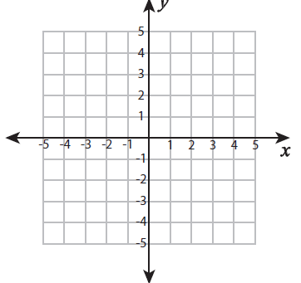
B

A

From the graph above
  - What are the coordinates of point A?

  - What are the coordinates of point B?

  - What is the gradient of the line?

  - How long is the line between points A and B?

  - What are the coordinates for the midpoint?

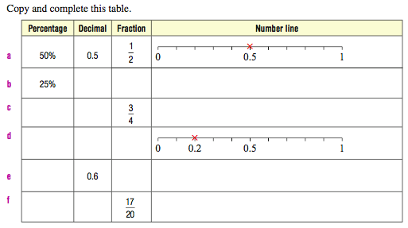
Probability

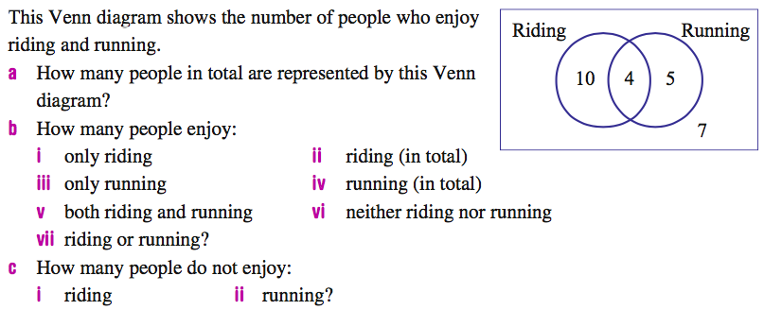

What is the probability of getting less than 4 when rolling a dice?
- $\frac{1}{6}$ b) 50% c) 0.4 d) 73% e) 0.8

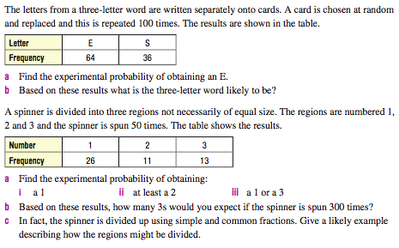

Data
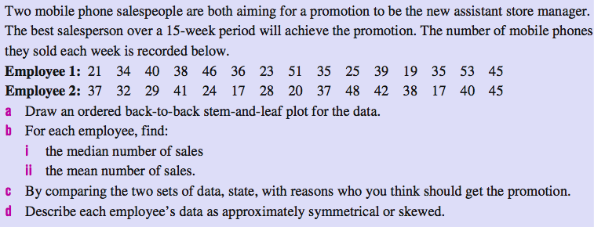

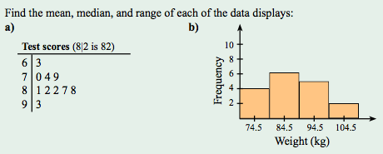

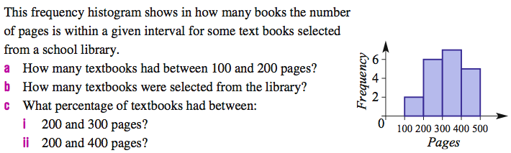

Trigonometry
